Saint Bridget Parish Council Minutes  
**Wednesday; March 19, 2025 (virtual)**

|  |  |
| --- | --- |
| Father Ken Shuping PRESENT  Rev. Seth Seaman PRESENT  Bruce Slough, Chairperson PRESENT  Allie Strollo, Secretary ABSENT  Pat Accardo PRESENT  Julia Williams ABSENT  Mike Wilder PRESENT | Frank Devenoge ABSENT  Tom Giannasi PRESENT  Kristine Keeney PRESENT  Mack Rich PRESENT  John Rogers PRESENT  Tara Chiudian ABSENT |

# Opening

* 6:02 PM – Meeting was called to order by Bruce Slough
* Opening prayer, Father Ken

# Approval of Minutes

* 6:03 PM Meeting minutes from February 2025 meeting were approved by the council

# Liaison Reports

## Liturgy – Mack Rich

Outdoor Stations:

Will be on April 11th, starting at 5pm. The last five stations will be in the church.

Parish office is working to publicize the Neighborhood Stations. Ushers are also being recruited to help direct traffic and participants.

Also that evening, setup will begin for a new sound system to be used for Palm Sunday.

Palm Sunday:

As in the past masses will begin outside on the terrace and an extra Lector will be assisting with the reading of the Passion.

Planning to use the Commons for seating at the 9am and 11am.

Chrism Mass:

Father Ken will attend at the Cathedral on April 14th and to receive the oils.

Holy Thursday:

Liturgy Committee is recruiting volunteers for Washing of the Feet.

Will sing the Gloria with bells; the bell tower bells will them be silenced until the Easter Vigil

After Mass, procession to the Altar of Repose and Adoration until approximately midnight.

Good Friday:

8am Morning Prayer

3pm Liturgy of the Lord's Passion with Veneration of the Cross and Eucharist offered.

5:30pm Stations of the Cross (no soup supper)

Holy Saturday:

8am Morning Prayer and Easter Basket blessing.

Basket donation drop-off too.

8:30pm Easter Vigil

Easter:

7:30 am Church w/ chairs in commons

9:00am Church w/ chairs in commons

9:15am MPH

11:00am Church w/ chairs in commons

ushers will direct people to MPH when the Church is full for the 9am.

Octave:

The whole week is a solemnity, so if there are altar servers every daily Mass will have bells and incense.

Divine Mercy Sunday:

Infant baptisms (at every mass?)

2pm Holy Hour with reconciliation offered, Divine Mercy group praying the Divine Mercy Chaplet

## Christian Formation-Kristine Keeney

* First Reconciliation just finished
* First Communion retreats up next
  + Mar 29, Apr 5
* VBS volunteers almost filled
  + Per signup genius
* Looking ahead to school calendar for next year, promoting adult formation during children’s faith formation once per month
  + Current parent formation is not strongly attended. Last one with Deacon VJ had zero attendees
  + Using free download pamphlet for CLOW and FF
* Apr 6 talk from Fr. Seth focusing on Holy Week and looking ahead to summertime
* Question: will the advisory committee for faith formation reconvene with Marisa back?
  + Unclear, Michael had created it as a personal effort

## Social Ministry- Julia Williams

* Father Ken raised the question of running the picnic in conjunction with the ministry fair.
  + Do we want to run it the same way this year?
  + Brief discussion about having it be a ticketed event, general support for it

Update over email:

1) I have discovered over the winter that other staff is present when afterhours/inclement

weather happens and we have a visitor looking for help. I am happy to offer a very brief

crash course about services immediately available and steps to follow for when/if these

situations arise. I also have resources to have handy. If you are interested in

participating, raise your hand and I will look to get something on the calendar for this.

2) Tomorrow- March 13th - will have the feeding ministry table needed/set up for the LVS

Group.

3) Remainder of March will see meetings with Haiti this evening in conjunction with the

Diocese, Walking with Moms and SVDP.

4) SVDP- will be hosting a spaghetti dinner on May 17th in the MPH from 5-8 pm. They will

be shadowing the KOC this week at the Fish Fry to understand their volunteer roles and

prepare for the event. There will be spaghetti with choice of meat sauce and marinara,

salad and bread, dessert and choice of beverages. We are also discussing a preorder

package of a meal to go for $30.00 which includes all the above available for pickup

through a pre-order only. This will be an educational event and fundraiser.

5) Walking with Moms is picking up steam and planning for an event on May 18th. It will

be a Mother’s Day Tea hosting moms from our partner agencies at Mary’s Choice RVA,

CCC- Seton Home, East End Pregnancy Center and the Pregnancy Resource Center. It will

be from 2-4 pm in the commons. The feeding ministry will be helping cater and the

MS/HS youth and MS Service team have been invited to help with the nursery. Mothers

will receive a keepsake and professional photo as well as enjoy fellowship with other

moms who chose life.

6) Social Ministry is targeting Sunday, September 7th, 2025 for a ministry fair event. It will

be the Sunday after Labor Day and working to determine space needs and also inviting

local partners to come and introduce their agency as well. More details to come.

7) In September we are also planning a joint Social Ministry and Youth program for

9/26/25. It will be an overnight lock out in the MPH parking lot hosting youth the

experience Cardboard Box City. This will also be a fundraiser and engagement event for

our youth to experience the uncomfortableness of homelessness for the night. It will

include a simple supper (like the St. Peter’s Door meal) and breakfast; we will host a

speaker from HFF(Housing Families First) or ACTS to share information on family

homelessness and also have a simulation and games. The event will end at 7 a.m.

Saturday and is an electronics free event. Fr. Ken has also encouraged us to invite youth

from sister parishes to join and we have a short list of those groups to include.

## Community Life and Evangelization – John Rogers

* Donuts on hold for Lent. After Easter, the parish will sponsor some weekends and Frank is building a donor list for others
* The fish fry was hopping!
  + Very well attended. John still seeking exact numbers / $$ raised from John McCulla
  + We discussed whether to do it more often, and acknowledged that probably we’d have to be less fancy (more like soup supper) to do that.
* Soup suppers have been well attended so far
  + ~50 people at the first one, sponsored by parish council (Thanks, Kristine!)
  + We should provide Restaurant Depot guidance for sponsors who want to buy food instead of making it. Kristine had planned soup for 30 folks, and that was barely within budget so we should seek bulk savings.
  + Tom G can provide guidance on how to order from Restaurant Depot
* Recent food drives have gone well. Feb food drive collected $3000 worth of food, $475 in donations, and Carol Ryan brought muffins to the K of C team

**Evangelical Catholic**

The Evangelical Catholic group has concluded its 12 sessions, and is now in the support phase for the eight people who were a part of the group. Deacon VJ and I (the two facilitators of the group) plan to meet monthly with this group for dinner, fellowship, encouragement and accountability. We have already met with them once for this. We will also have quarterly meetings with them for ongoing formation. Of the eight participants in the group, seven of them will be starting new apostolates (an apostolate is different than a ministry; a ministry is ultimately a function/outworking of the pastor’s ministry in the parish, an apostolate is a work that one does from gifts of the Holy Spirit that may be done independently of the parish’s ministry). The remaining one will continue with the apostolate that he had already started some time ago. Here is a list of what each group member plans to do:

* Person 1 & 2 together: Couples mentoring **(new)**
* Person 3: Ladies group **(new)**
* Person 4: Bible Study (existing)
* Person 5: Friend mentoring **(new)**, also possible future facilitator for Evangelical Catholic
* Person 6: Couples mentor **(new)**
* Person 7: Bible Study with family **(new)**
* Person 8: Youth mentoring **(new)**, Men’s group with neighbors **(new)**

Many of the people in this group were not very confident in themselves or their ability to do anything significant at the beginning of this program. However, at the end of it, nearly everyone was very confident in themselves and the fact that God could do something meaningful through them. As a result, they are all stepping out in faith and trying lead people closer to Jesus intentionally.

There are a few months left on our 1-year subscription to Evangelical Catholic’s “Reach More” program. I would say it has been a great success. Honestly, it has produced more than I could have hoped for. With this in mind, it is a very expensive program (especially since it includes a mandatory consultant for the facilitators for the first two years), costing $10,0000 per year for the first two years, and then $2,500 per year after that. We were able to find a few donors to pay for the most of the first year, and will need more donor funds if we are to have a second year.

# Pastor Report

* The robotics team from the middle school is moving on to the nationals!

# Principal Report

* <Allie absent>

# Old Business

* Nursery
  + Marisa has been researching nursery care
    - Number of staff required (1 per 10 children from 2-4, 1 per 5 children from 16-24 months)
    - Question: does this make it harder / disallowed for parents to come and stay with their own kids? Marisa to research.
    - Question: can Marisa also research what other local parishes are doing to look for models we can follow, and ascertain where and how we would recruit for the nursery?
  + Mack: might need to check Virtus rules to see if they’re stricter
  + Tom Gianassi texted some folks at St. Mary’s and confirmed that their nursery is staffed by volunteers, at their 9am Mass
  + John texted some parishioners and heard back that pre-pandemic, we had two paid nursery staff, and required any parents who used the nursery to rotate as volunteers once every few weeks. We used both the nursery we have today as well as what is now the choir rehearsal room, and split children between them based on age.
* Disciple Maker Index goals
  + Engagement: Bruce, Frank, Jo Ellen
  + Workshops: Marisa, Kristine
  + Mentorship: Fr. Seth, Mike Wilder
  + Survey + Stats: John, Pat, Lizzie
* Parish incorporation - no significant news
  + Longer window - more like 6 months to go through this
  + Richmond parishes starting first, either the east or west deanery
  + Still waiting to see boilerplate articles of incorporation
  + K of C (Columbian Center) was asked to provide a separate rider of insurance, unclear why and Tom is looking into it.

# New Business

* Add QR code for giving in bulletin?
  + John to email example to Father Ken
  + Father Ken to consider with the staff member responsible for worship aids
  + Here's the example (attached image, from Cathedral of the Sacred Heart) of putting the QR code for offertory inline in their worship aid. I think it's pretty discreet and understated, and a good way to reach one-time visitors or folks who don't have cash in their wallet.

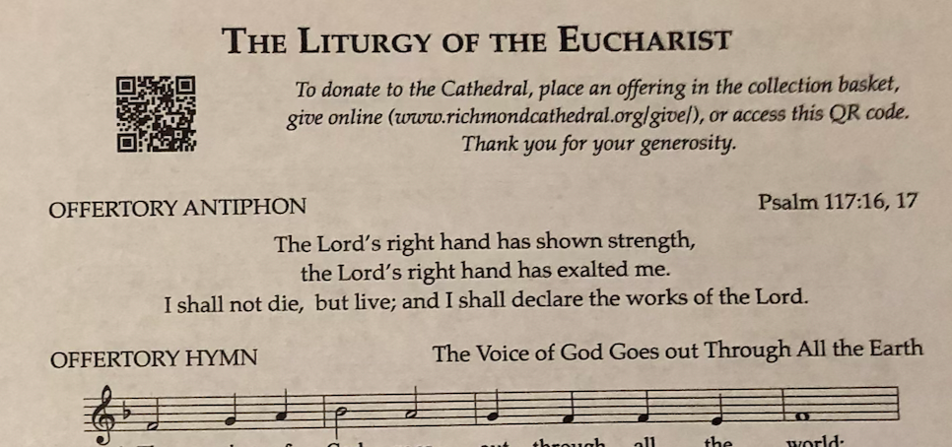

* + Their giving page is also very friendly and visually appealing and makes it easy to see what you can donate to: <https://secure.myvanco.com/L-ZABM/home>. St. Bridget's is a little harder to figure out, especially on a phone, since you have to open the "Fund" dropdown and then know that "Offertory - Stewardship" is what you pick to make a regular Sunday donation: <https://giving.parishsoft.com/App/Giving/ncs-1403>
  + I have also visited a church that had a small stand by the exit with a tablet mounted on it that had a payment app open. As visitors, we were easily able to make a donation with our phones by tapping to pay on the tablet. That obviously takes more setup from the parish, but worth considering to reduce friction even more.
  + Making it easy for Mass attendees to give without needing cash or an account setup process is very likely to pay off in increased offertory.
* Identifying candidates for next year’s parish council
  + Work backwards from our deadlines - May weekends are quite full already
  + Nominations May 11, 18, 25, Elections on June 1
  + Everyone on council should nominate at least one candidate
  + Nominees should send a photo and bio (one paragraph, who are you and why do you feel called to parish council) to send to nomination subcommittee (which is Bruce + Mack)
* Roof discoloration near the back of the church?
  + Not mold, just discoloration
  + Already have investigated it and made a plan to get scaffolding in in October to repaint the area

# Parishioner Feedback/Suggestion Box

* <none this time>

# Adjournment

* Meeting adjourned 7:00 PM **on the dot!**